**PYTHON ASSIGNMENT – 4**

**Q1. Write a Program to print new list which contains all the first Characters of strings present in a list.....**

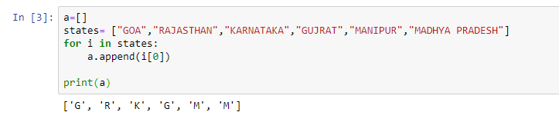

**Q2. Write a program to replace each string with an integer value in a given list of strings. The replacement integer value should be a sum of AScci values of each character of type corresponding string........**

**LIST: ['GAnga', 'Tapti', 'Kaveri', 'Yamuna', 'Narmada' ]**

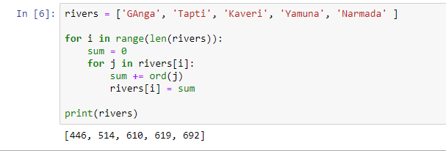

**Q3.** **###### You have to run your Program at 9:00am. Date: 14th April 2020.**

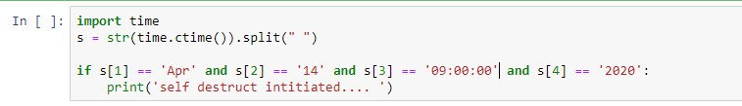

**Q4. GIve a tuple:**

**tuple = ('a','l','g','o','r','i','t','h','m')**

**1. Using the concept of slicing, print the whole tuple**

**2. delete the element at the 3rd Index, print the tuple.**

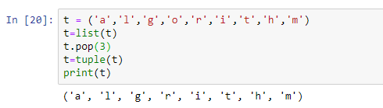

**Q5. Take a list REGex=[1,2,3,4,5,6,7,8,9,0,77,44,15,33,65,89,12]**

**- print only those numbers greator then 20**

**- then print those numbers those are less then 10 or equal to 10**

**- store these above two list in two different list.**

